Journal Submission Report

Masters of
Computer Application

Dr. Vishwanath Karad MIT World Peace University
(MIT-WPU)
Department of Computer Science & Applications
ADVANCED DATABASE MANAGEMENT SYSTEMS
LAB JOURNAL
Subject Code: | MCA40180
Academic Year: | 2025 - 26
Semester: | 1st

Student Detail:
Name: | Ranpariya Yash
Roll Number: | 1272251066
Course & Section: | FYMCA ‘E’

Submitted To:
Faculty In-Charge: | Mrs. Dinesh Banswal  Designation : Professor

CONTENTS

Assignment No. | Assignment Title
1 | Basic Programs
2 | Arrays, Classes, and Command Line Args
3 | Palindromes, Primes, and Patterns
4 | Command Line, Series, and Patterns
5 | Classes and Array Operations
6 | 1D and 2D Array Operations
7 | Inheritance, Abstract Classes, and Interfaces
8 | Exception Handling
9 | Multithreading
10 | File Handling

Assignment 1

1. Write a Java program to print the sum, multiply, subtract, divide and remainder
of two numbers
import java.util.*;

public class ArithmeticOperations {
public static void main(String args[]){
Scanner sc = new Scanner(System.in);
System.out.print("Enter No1:");
int num1 = sc.nextInt();
System.out.print("Enter No2:");
int num2 = sc.nextInt();

System.out.println("Sum:" + (num1 + num2));
System.out.println("Subtraction:" + (num1 - num2));
System.out.println("Multiplication:" + (num1 * num2));
System.out.println("Division:" + (num1 / num2));
System.out.println("Remainder:" + (num1 % num2));

}
}
Output:
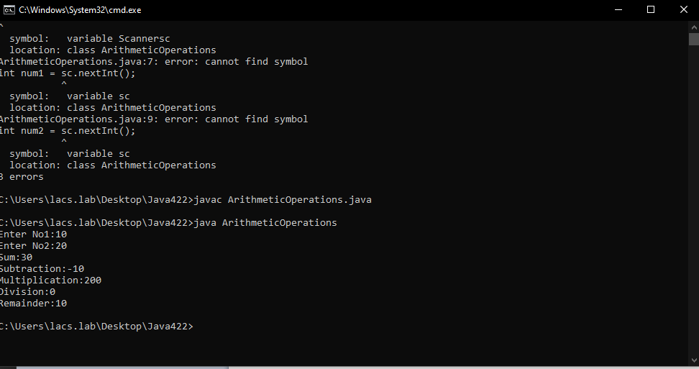
===========================================================================

2. Write a Java program that takes five numbers as input to calculate and print the
average of the numbers
import java.util.*;
public class AverageCalculate{
public static void main(String args[]){
Scanner sc = new Scanner(System.in);
int sum = 0;

System.out.println("Enter 5 numbers:");
for(int i=0; i<5; i++){
sum += sc.nextInt();
}
double average = sum /5;
System.out.println("Average" + average);
}
}

Output:
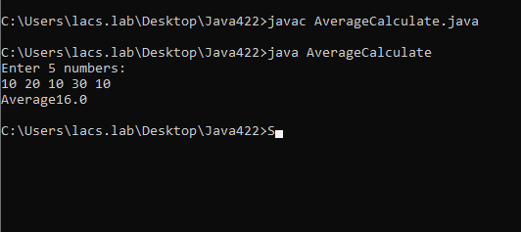
===========================================================================
3. Write a Java program to convert a decimal number to binary numbers
import java.util.*;
public class DecimalToBinary{
public static void main(String args[]){
Scanner sc = new Scanner(System.in);

System.out.print("Enter Decimal number:");
int decimal= sc.nextInt();
String binary = Integer.toBinaryString(decimal);
System.out.println("Binary representation: " + binary);
}
}

Output:
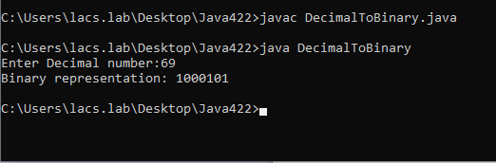
===========================================================================
4. Write a Java program to convert a binary number to decimal number
import java.util.*;
public class BinaryToDecimal{
public static void main (String args[]){
Scanner sc = new Scanner(System.in);

System.out.print("Enter binary no: ");
String binary = sc.nextLine();
int decimal = Integer.parseInt(binary , 2);
System.out.print("Decimal Represent: " + decimal);
}
}
Output:
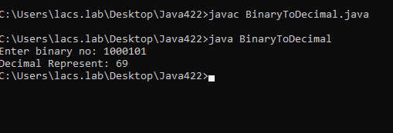
===========================================================================
5. Write a Java program and compute the sum of the digits of an integer
import java.util.*;
public class SumOfDigit{
public static void main(String args[]){
Scanner sc = new Scanner(System.in);
System.out.print("Enter an Integer: ");
int number = sc.nextInt();
int sum = 0;
int original = number;
number = Math.abs(number);
while(number > 0){
sum += number % 10;
number /= 10;
}
System.out.println("Sum of digit of" + original + "is :" + sum);
}
}
Output:
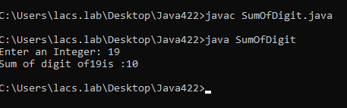
===========================================================================
6. Write a Java program to compare two numbers
import java.util.*;
public class CompareNumber{
public static void main(String args[]){
Scanner sc = new Scanner(System.in);
System.out.print("Enter no1 :");
int num1 = sc.nextInt();
System.out.print("Enter no2 :");
int num2 = sc.nextInt();
if(num1 > num2 ){
System.out.println(num1 + "is greater than " + num2);
}
else if(num1 < num2){
System.out.println(num1 + "is smaller than" + num2);
}else{
System.out.println(num1 + "is equal to " + num2);
}
}
}
Output:
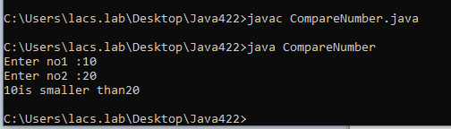
===========================================================================
7. Write a Java program to count the letters, spaces, numbers, and other characters
of an input string
import java.util.*;
public class CharacterCounter{
public static void main (String args[]){
Scanner sc = new Scanner(System.in);

System.out.print("Enter Your String: ");
String input = sc.nextLine();

int letter = 0, digit = 0 ,spaces =0 ,other = 0;

for (int i=0; i < input.length(); i++){
char ch = input.charAt(i);

if(Character.isLetter(ch)){
letter++;
}else if(Character.isDigit(ch)){
digit++;
}else if(Character.isWhitespace(ch)){
spaces++;
}else{
other++;
}
}
System.out.println("Letter: " + letter);
System.out.println("Digits: " + digit);
System.out.println("Letter: " + spaces);
System.out.println("other Charaters: " + other);

}

}

Output:
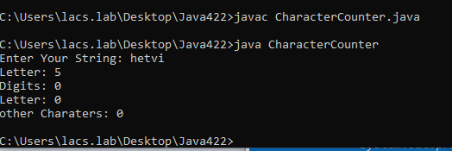
===========================================================================
8. Write a Java program to print the even and odd numbers from 1 to 20 by using
call to two different methods belongs same super class
public class NumberPrinter{
public void PrintEven(){
System.out.println("Even Numbersfrom 1 to 20:");
for(int i=2; i <= 20; i += 2){
System.out.print(i + " ");
}
System.out.println();
}
public void PrintOdd(){
System.out.println("Odd numbers from 1 to 20:");
for(int i=1; i<= 20; i+= 2){
System.out.print(i + " ");
}
System.out.println();
}
public static void main (String args[]){
NumberPrinter np = new NumberPrinter();
np.PrintEven();
np.PrintOdd();
}
}

Output:
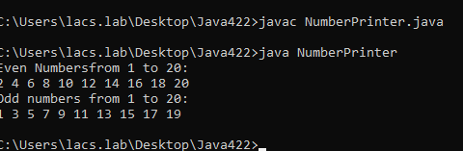
===========================================================================
9. Write a Java program to compute the sum of the first 100 prime numbers
public class PrimeNoSum{
public static void main(String[] args) {
int count = 0, num = 2, sum = 0;
while (count < 100) {
if (isPrime(num)) {
sum += num;
count++;
}
num++;
}
System.out.println("Sum of first 100 primes: " + sum);
}

static boolean isPrime(int n) {
if (n < 2) return false;
for (int i = 2; i <= n / 2; i++)
if (n % i == 0) return false;
return true;

}

}

Output:
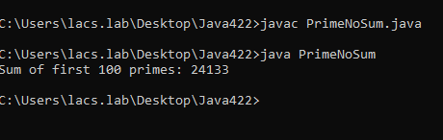
===========================================================================
10. Write a Java program to swap the first and last elements of an array and create a
new array
import java.util.Arrays;
public class SwapArray {
public static void main(String[] args) {
int[] arr = {1, 2, 3, 4, 5};
int[] newArr = arr.clone();
int temp = newArr[0];
newArr[0] = newArr[newArr.length - 1];
newArr[newArr.length - 1] = temp;
System.out.println("New Array: " + Arrays.toString(newArr));
}
}
Output:
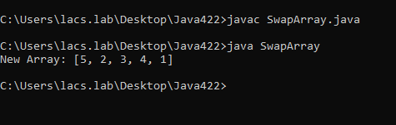
===========================================================================
11. Write a Java program to count the number of even and odd elements in a given
array
public class EvenOddCount {
public static void main(String[] args) {
int[] arr = {1, 4, 7, 10, 13};
int even = 0, odd = 0;
for (int num : arr) {
if (num % 2 == 0) even++;
else odd++;
}
System.out.println("Even: " + even + ", Odd: " + odd);
}
}
Output:
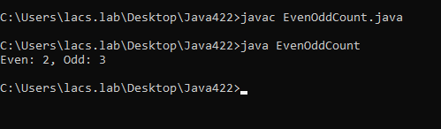
===========================================================================
12. Write a Java program to check if a positive number is a palindrome or not
import java.util.Scanner;
public class Palindrome
{
public static void main(String []args){
Scannersc = new Scanner(System.in);
int n=121;
int original =n;
int reversed =0 ;
while(n>0){
int last = n% 10;
reversed = reversed * 10 + last;
n=n/10;
}
if(original == reversed){
System.out.println(original + "is a Palindrome");
}else{
System.out.println(original + "is not a Palindrome");
}
}
}
Output:
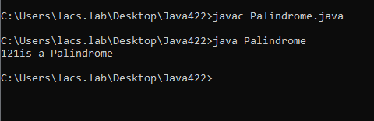
===========================================================================
13. Write a Java program to add two numbers without using any arithmetic
operators
public class AddWithoutOperators {
public static void main(String[] args) {
int a = 5, b = 7;
while (b != 0) {
int carry = a & b;
a = a ^ b;
b = carry << 1;
}
System.out.println("Sum: " + a);
}
}
Output:
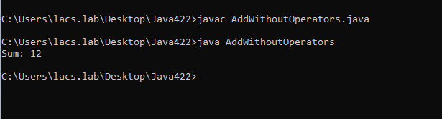
===========================================================================
14. Write a Java program to add all the digits of a given positive integer
import java.util.Scanner;

public class SumDigits {
public static void main(String[] args) {
Scanner sc = new Scanner(System.in);

System.out.print("Enter a positive integer: ");
int number = sc.nextInt();

int sum = 0;
while (number > 0) {
sum += number % 10;
number /= 10;
}

System.out.println("Sum of the digits: " + sum);
}
}
Output:
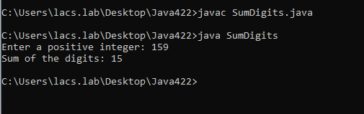
===========================================================================
15. Write a java program to Compute the Sum of the Principal and Secondary
Diagonals elements of a Matrix
public class MatrixDiagonalSum {
public static void main(String[] args) {
int[][] matrix = {
{1, 2, 3},
{4, 5, 6},
{7, 8, 9}
};
int primary = 0, secondary = 0;
for (int i = 0; i < matrix.length; i++) {
primary += matrix[i][i];
secondary += matrix[i][matrix.length - 1 - i];
}
System.out.println("Primary Diagonal Sum: " + primary);
System.out.println("Secondary Diagonal Sum: " + secondary);
}
}
Output:

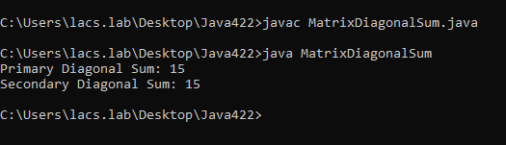

ASSIGNMENT : 2
- Write a Java program to swap the first and last elements of an array and create a new array
CODE:-
class Main {
public static void main(String[] args) {
int[] arr = {10, 20, 30, 40, 50};

int temp = arr[0];
arr[0] = arr[arr.length - 1];
arr[arr.length - 1] = temp;

System.out.print("New array: ");
for (int x : arr)
System.out.print(x + " ");
}
}
OUTPUT:-

- Write a Java program to count the number of even and odd elements in a given array
CODE:
class Main {
public static void main(String[] args) {
int[] arr = {1, 2, 3, 4, 5, 6};
int even = 0, odd = 0;

for (int n : arr) {
if (n % 2 == 0)
even++;
else
odd++;
}

System.out.println("Even numbers: " + even);
System.out.println("Odd numbers: " + odd);
}
}

OUTPUT:-
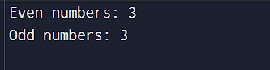
- Write a Java program to check if a positive number is a palindrome or not
CODE:-
import java.util.Scanner;
class Main {
public static void main(String[] args) {
Scanner sc = new Scanner(System.in);
System.out.print("Enter number: ");
int n = sc.nextInt(), rev = 0, temp = n;

while (n > 0) {
rev = rev * 10 + n % 10;
n /= 10;
}

if (temp == rev)
System.out.println("Palindrome");
else
System.out.println("Not Palindrome");
}
}
OUTPUT:-
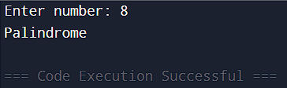
- Write a Java program to add two numbers without using any arithmetic operators
CODE:
class Main {
public static void main(String[] args) {
int a = 5, b = 7;
while (b != 0) {
int carry = a & b;
a = a ^ b;
b = carry << 1;
}
System.out.println("Sum = " + a);
}
}
OUTPUT:-
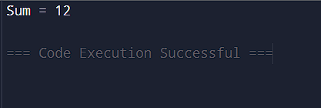
- Write a Java program to add all the digits of a given positive integer
CODE:-
public class AddDigits {
public static void main(String[] args) {
int num = 12345;
int sum = 0;

while (num > 0) {
sum += num % 10;
num = num / 10;
}

System.out.println("Sum of digits: " + sum);
}
}
OUTPUT:

- Write a java program to Compute the Sum of the Principal and Secondary Diagonals elements of a Matrix
CODE:
public class MatrixDiagonals {
public static void main(String[] args) {
int[][] matrix = {
{1, 2, 3},
{4, 5, 6},
{7, 8, 9}
};

int principal = 0;
int secondary = 0;
int n = matrix.length;

for (int i = 0; i < n; i++) {
principal += matrix[i][i];
secondary += matrix[i][n - 1 - i];
}

System.out.println("Principal diagonal: " + principal);
System.out.println("Secondary diagonal: " + secondary);
}
}
OUTPUT:
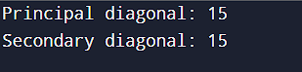
- Write a Java program which will accept a number from the command line argument and check whether it is palindrome or not.
CODE:
public class CmdPalindrome {
public static void main(String[] args) {
if (args.length > 0) {
int num = Integer.parseInt(args[0]);
int original = num;
int reverse = 0;

while (num > 0) {
int digit = num % 10;
reverse = reverse * 10 + digit;
num = num / 10;
}

if (original == reverse) {
System.out.println("Palindrome");
} else {
System.out.println("Not Palindrome");
}
}
}
}

- Define class Staff with data members as name, birth-date, designation and salary. Use constructors and method display () –which will display details of Staff. Create two objects of Staff and Print the name of staff having highest salary.
CODE:
class Staff {
String name;
String birthDate;
String designation;
double salary;

Staff(String n, String bd, String d, double s) {
name = n;
birthDate = bd;
designation = d;
salary = s;
}

void display() {
System.out.println("Name: " + name);
System.out.println("Birth Date: " + birthDate);
System.out.println("Designation: " + designation);
System.out.println("Salary: " + salary);
}
}

public class StaffMain {
public static void main(String[] args) {
Staff s1 = new Staff("John", "01/01/1990", "Manager", 50000);
Staff s2 = new Staff("Mike", "15/06/1985", "Director", 75000);

if (s1.salary > s2.salary) {
System.out.println("Highest salary: " + s1.name);
} else {
System.out.println("Highest salary: " + s2.name);
}
}
}
OUTPUT:-


- Define class Bank with data members as Cust_name, Ac_no and balance. Use constructors and method withdraw and deposit. Print the balance according to operation.
CODE:
class Bank {
String custName;
int acNo;
double balance;

Bank(String name, int ac, double bal) {
custName = name;
acNo = ac;
balance = bal;
}

void withdraw(double amount) {
if (amount <= balance) {
balance -= amount;
System.out.println("Withdrawal successful. Balance: " + balance);
} else {
System.out.println("Insufficient balance");
}
}

void deposit(double amount) {
balance += amount;
System.out.println("Deposit successful. Balance: " + balance);
}
}

public class BankMain {
public static void main(String[] args) {
Bank acc = new Bank("Alice", 12345, 10000);
acc.deposit(5000);
acc.withdraw(2000);
}
}
OUTPUT:-
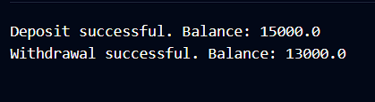

- Accept 5 numbers from command line argument and print it in the ascending order. (Use array)
CODE:
public class SortNumbers {
public static void main(String[] args) {
if (args.length == 5) {
int[] arr = new int[5];

for (int i = 0; i < 5; i++) {
arr[i] = Integer.parseInt(args[i]);
}

for (int i = 0; i < 4; i++) {
for (int j = 0; j < 4 - i; j++) {
if (arr[j] > arr[j + 1]) {
int temp = arr[j];
arr[j] = arr[j + 1];
arr[j + 1] = temp;
}
}
}

for (int i = 0; i < 5; i++) {
System.out.print(arr[i] + " ");
}
}
}
}

OUTPUT:
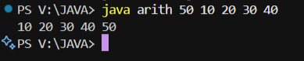
- Write a Java program which will accept 3 X 4 matrix and print the row wise and column-wise addition of numbers.
CODE:
public class MatrixAddition {
public static void main(String[] args) {
int[][] matrix = {
{1, 2, 3, 4},
{5, 6, 7, 8},
{9, 10, 11, 12}
};

System.out.println("Row-wise addition:");
for (int i = 0; i < 3; i++) {
int rowSum = 0;
for (int j = 0; j < 4; j++) {
rowSum += matrix[i][j];
}
System.out.println("Row " + (i + 1) + ": " + rowSum);
}

System.out.println("Column-wise addition:");
for (int j = 0; j < 4; j++) {
int colSum = 0;
for (int i = 0; i < 3; i++) {
colSum += matrix[i][j];
}
System.out.println("Column " + (j + 1) + ": " + colSum);
}
}
}
OUTPUT:
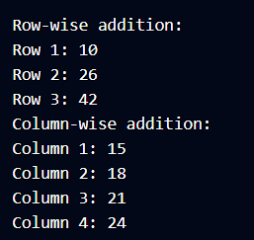
- Write a java program to print multiplication of Matrix.
CODE:
public class MatrixMultiplication {
public static void main(String[] args) {
int[][] a = {
{1, 2, 3},
{4, 5, 6}
};

int[][] b = {
{7, 8},
{9, 10},
{11, 12}
};

int[][] result = new int[2][2];

for (int i = 0; i < 2; i++) {
for (int j = 0; j < 2; j++) {
for (int k = 0; k < 3; k++) {
result[i][j] += a[i][k] * b[k][j];
}
}
}

for (int i = 0; i < 2; i++) {
for (int j = 0; j < 2; j++) {
System.out.print(result[i][j] + " ");
}
System.out.println();
}
}
}

OUTPUT:
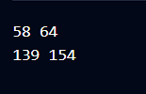
- Create student class having data member (roll no, name, percentage) accept values and display details (use command line argument)
CODE:
class Student {
int rollNo;
String name;
double percentage;

Student(int r, String n, double p) {
rollNo = r;
name = n;
percentage = p;
}

void display() {
System.out.println("Roll No: " + rollNo);
System.out.println("Name: " + name);
System.out.println("Percentage: " + percentage);
}
}

public class StudentMain {
public static void main(String[] args) {
if (args.length >= 3) {
int rollNo = Integer.parseInt(args[0]);
String name = args[1];
double percentage = Double.parseDouble(args[2]);

Student s = new Student(rollNo, name, percentage);
s.display();
}
}
}
OUTPUT:
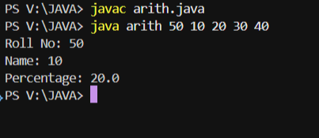

ASSIGNMENT 3

- Write a Java Program to accept two numbers and a character(+,-,*,/) from the command line argument and print the result according to character. (Use switch)
CODE:
public class CmdCalculator {
public static void main(String[] args) {
if (args.length == 3) {
double num1 = Double.parseDouble(args[0]);
double num2 = Double.parseDouble(args[1]);
char operator = args[2].charAt(0);

double result = 0;

switch (operator) {
case '+': result = num1 + num2; break;
case '-': result = num1 - num2; break;
case '*': result = num1 * num2; break;
case '/': result = num2 != 0 ? num1 / num2 : Double.NaN; break;
default: System.out.println("Invalid operator!");
return;
}

System.out.println("Result: " + result);
} else {
System.out.println("Usage: java CmdCalculator <num1> <num2> <operator>");
}
}
}
- Write a Java Program to accept Five numbers from the command line argument and
    - Print the smallest number.
    - Average of all numbers
    - Ascending order
    - Descending order
    - Print the smallest number.
CODE:
import java.util.Arrays;

public class FiveNumbers {
public static void main(String[] args) {
if (args.length == 5) {
int[] arr = new int[5];
int sum = 0;

// Convert command-line arguments to integers
for (int i = 0; i < 5; i++) {
arr[i] = Integer.parseInt(args[i]);
sum += arr[i];
}

// Sort the array
Arrays.sort(arr);

// Calculate average
double average = sum / 5.0;

// Print results
System.out.println("Smallest Number: " + arr[0]);
System.out.println("Average of all numbers: " + average);

System.out.print("Ascending Order: ");
for (int i = 0; i < 5; i++) {
System.out.print(arr[i] + " ");
}

System.out.print("\nDescending Order: ");
for (int i = 4; i >= 0; i--) {
System.out.print(arr[i] + " ");
}

System.out.println("\nSmallest Number (reprinted): " + arr[0]);
} else {
System.out.println("Please enter exactly 5 numbers as command-line arguments.");
}
}
}

OUTPUT:
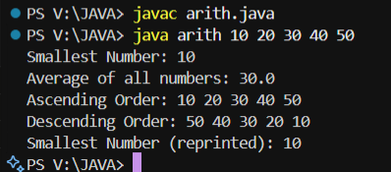

- WAP to accept the number from command line and print the multiplication of the same number
CODE:
public class CmdMultiplication {
public static void main(String[] args) {
if (args.length == 1) {
int num = Integer.parseInt(args[0]);

System.out.println("Multiplication Table of " + num + ":");
for (int i = 1; i <= 10; i++) {
System.out.println(num + " x " + i + " = " + (num * i));
}
} else {
System.out.println("Please enter exactly one number as command-line argument.");
}
}
}
OUTPUT
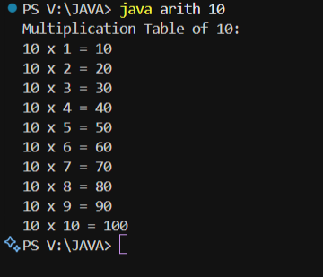
- WAP to print the addition of following series 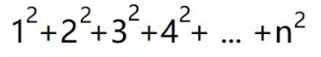
CODE:
public class SumOfSquares {
public static void main(String[] args) {
if (args.length == 1) {
int n = Integer.parseInt(args[0]);
int sum = 0;

System.out.print("Series: ");
for (int i = 1; i <= n; i++) {
System.out.print(i + "^2");
if (i < n) System.out.print(" + ");
sum += i * i;
}

System.out.println("\nSum of series = " + sum);
} else {
System.out.println("Please enter exactly one number as command-line argument.");
}
}
}
OUTPUT:
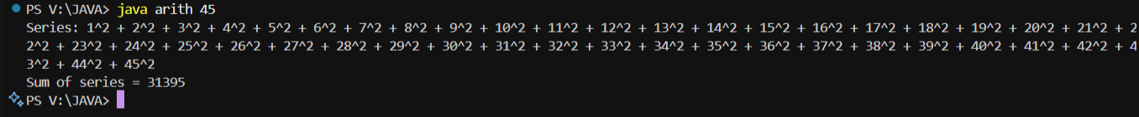

- WAP to Print the summation of series 1-2+3-4+5-6+7- ……….
e.g input is 7 then output is 4
CODE:
public class AlternateSeriesSum {
public static void main(String[] args) {
if (args.length == 1) {
int n = Integer.parseInt(args[0]);
int sum = 0;

for (int i = 1; i <= n; i++) {
if (i % 2 == 0)
sum -= i; // subtract even numbers
else
sum += i; // add odd numbers
}

System.out.println("Summation of series up to " + n + " terms = " + sum);
} else {
System.out.println("Please enter exactly one number as command-line argument.");
}
}
}

OUTPUT:
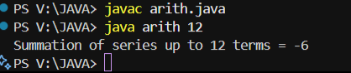
- WAP to print following pattern
1
2 3 4
3 4 5 4 3
4 5 6 7 6 5 4
5 6 7 8 9 8 7 6 5

CODE:
public class NumberPattern {
public static void main(String[] args) {
int n = 5; // total rows

for (int i = 1; i <= n; i++) {
// print leading spaces
for (int s = n; s > i; s--) {
System.out.print("\t");
}

// increasing numbers
for (int j = i; j <= (2 * i - 1); j++) {
System.out.print(j + "\t");
}

// decreasing numbers
for (int j = (2 * i - 2); j >= i; j--) {
System.out.print(j + "\t");
}

System.out.println();
}
}
}

OUTPUT:
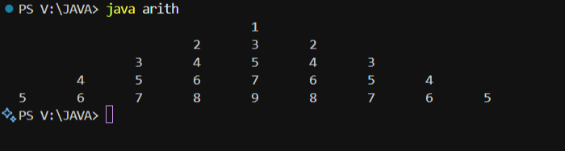

- WAP to define class called StudentInofo, having a parameterised constructor which will accept the input as StudPRN,StudName,StudGender,StudContactNumber.
Also define method called display().
Define one more class called StudentERP from that call accept the user input for define constructor in the class StudentInofo, call display() method by creating object of that class and display the students information.
CODE:
import java.util.Scanner;

// Class to store student information
class StudentInfo {
int studPRN;
String studName;
String studGender;
String studContactNumber;

// Parameterized constructor
StudentInfo(int prn, String name, String gender, String contact) {
studPRN = prn;
studName = name;
studGender = gender;
studContactNumber = contact;
}

// Method to display student details
void display() {
System.out.println("\n--- Student Information ---");
System.out.println("PRN: " + studPRN);
System.out.println("Name: " + studName);
System.out.println("Gender: " + studGender);
System.out.println("Contact Number: " + studContactNumber);
}
}

// Main class
public class StudentERP {
public static void main(String[] args) {
Scanner sc = new Scanner(System.in);

System.out.print("Enter Student PRN: ");
int prn = sc.nextInt();
sc.nextLine(); // consume newline

System.out.print("Enter Student Name: ");
String name = sc.nextLine();

System.out.print("Enter Student Gender: ");
String gender = sc.nextLine();

System.out.print("Enter Student Contact Number: ");
String contact = sc.nextLine();

// Create object and call constructor
StudentInfo student = new StudentInfo(prn, name, gender, contact);

// Display student info
student.display();

sc.close();
}
}

OUTPUT:
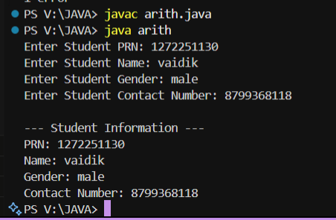

ASSIGNMENT:4

(1)Define class Staff with data members as name, birth-date, designation and salary. Use constructors and method display () –which will display details of Staff. Create two objects of Staff and Print the name of staff having highest salary.

CODE:
class Staff {
String name, birthDate, designation;
double salary;

// Parameterized constructor
Staff(String name, String birthDate, String designation, double salary) {
this.name = name;
this.birthDate = birthDate;
this.designation = designation;
this.salary = salary;
}

// Method to display staff details
void display() {
System.out.println("Name: " + name);
System.out.println("Birth Date: " + birthDate);
System.out.println("Designation: " + designation);
System.out.println("Salary: " + salary);
System.out.println("--------------------------");
}

// Method to get salary
double getSalary() {
return salary;
}
}

public class StaffMain {
public static void main(String[] args) {
// Creating two staff objects
Staff s1 = new Staff("Vaidik", "12-03-1999", "Manager", 60000);
Staff s2 = new Staff("Raj", "05-08-1998", "Assistant", 45000);

System.out.println("----- Staff Details -----");
s1.display();
s2.display();

// Compare salary and print name of highest salary holder
if (s1.getSalary() > s2.getSalary()) {
System.out.println("Highest Salary: " + s1.name);
} else {
System.out.println("Highest Salary: " + s2.name);
}
}
}

OUTPUT:
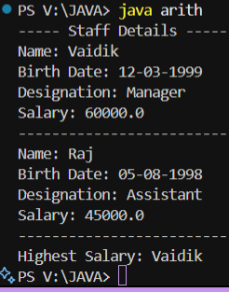

Program -02
Define class Bank with data members as Cust_name, Ac_no and balance. Use constructors and method withdraw and deposit. Print the balance according to operation.

CODE:

import java.util.Scanner;

class Bank {
String custName;
int acNo;
double balance;

// Parameterized Constructor
Bank(String custName, int acNo, double balance) {
this.custName = custName;
this.acNo = acNo;
this.balance = balance;
}

// Method to deposit money
void deposit(double amount) {
if (amount > 0) {
balance += amount;
System.out.println("Amount Deposited: ₹" + amount);
} else {
System.out.println("Invalid deposit amount!");
}
}

// Method to withdraw money
void withdraw(double amount) {
if (amount > 0 && amount <= balance) {
balance -= amount;
System.out.println("Amount Withdrawn: ₹" + amount);
} else {
System.out.println("Insufficient balance or invalid amount!");
}
}

// Method to display account details
void display() {
System.out.println("\n----- Account Details -----");
System.out.println("Customer Name: " + custName);
System.out.println("Account Number: " + acNo);
System.out.println("Current Balance: ₹" + balance);
}
}

public class BankMain {
public static void main(String[] args) {
Scanner sc = new Scanner(System.in);

// Accept user input for bank account details
System.out.print("Enter Customer Name: ");
String name = sc.nextLine();
System.out.print("Enter Account Number: ");
int acNo = sc.nextInt();
System.out.print("Enter Initial Balance: ₹");
double balance = sc.nextDouble();

// Create Bank object
Bank customer = new Bank(name, acNo, balance);

// Display menu for deposit or withdraw
System.out.println("\nChoose Operation:");
System.out.println("1. Deposit");
System.out.println("2. Withdraw");
int choice = sc.nextInt();

if (choice == 1) {
System.out.print("Enter amount to deposit: ₹");
double amt = sc.nextDouble();
customer.deposit(amt);
} else if (choice == 2) {
System.out.print("Enter amount to withdraw: ₹");
double amt = sc.nextDouble();
customer.withdraw(amt);
} else {
System.out.println("Invalid choice!");
}

// Display updated account details
customer.display();

sc.close();
}
}

OUTPUT:

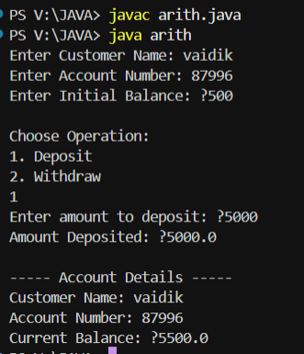

Program -03
Accept 5 numbers in the array
- print it in the ascending order.
- print the row wise addition of numbers.
- Average of the numbers
- Check whether the number is present in the array if present return index of the number
- Check whether the prime number is present in the array if present return the prime number with its index of the number.

CODE:

import java.util.Scanner;

import java.util.Arrays;

public class ArrayOperations {

public static void main(String[] args) {

Scanner sc = new Scanner(System.in);

int[] arr = new int[5];

int sum = 0;

// Accept 5 numbers from user

System.out.println("Enter 5 numbers:");

for (int i = 0; i < 5; i++) {

arr[i] = sc.nextInt();

sum += arr[i];

}

// a. Print in ascending order

int[] ascending = arr.clone();

Arrays.sort(ascending);

System.out.println("\nAscending Order: " + Arrays.toString(ascending));

// b. Print the row-wise addition (sum of all numbers)

System.out.println("Row-wise Addition (Sum of all numbers): " + sum);

// c. Average of numbers

double avg = sum / 5.0;

System.out.println("Average of numbers: " + avg);

// d. Check whether a number is present in the array

System.out.print("\nEnter a number to search: ");

int search = sc.nextInt();

boolean found = false;

for (int i = 0; i < 5; i++) {

if (arr[i] == search) {

System.out.println("Number " + search + " found at index: " + i);

found = true;

break;

}

}

if (!found)

System.out.println("Number not found in the array.");

// e. Check prime numbers in array and print with index

System.out.println("\nPrime numbers present in the array:");

boolean primeFound = false;

for (int i = 0; i < 5; i++) {

if (isPrime(arr[i])) {

System.out.println("Prime Number: " + arr[i] + " at Index: " + i);

primeFound = true;

}

}

if (!primeFound)

System.out.println("No prime numbers found in the array.");

sc.close();

}

// Method to check if number is prime

public static boolean isPrime(int num) {

if (num <= 1)

return false;

for (int i = 2; i <= num / 2; i++) {

if (num % i == 0)

return false;

}

return true;

}

}

OUTPUT:

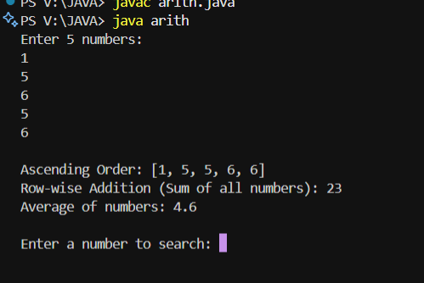

ASSIGNMENT 5
Program -01
Write a program to accept 2D array and Print addition of two matrixes

CODE:
import java.util.Scanner;
public class MatrixAddition {
public static void main(String[] args) {
Scanner sc = new Scanner(System.in);
int[][] a = new int[3][3];
int[][] b = new int[3][3];
int[][] sum = new int[3][3];

System.out.println("Enter first 3x3 matrix:");
for (int i = 0; i < 3; i++)
for (int j = 0; j < 3; j++)
a[i][j] = sc.nextInt();

System.out.println("Enter second 3x3 matrix:");
for (int i = 0; i < 3; i++)
for (int j = 0; j < 3; j++)
b[i][j] = sc.nextInt();

// Matrix Addition
System.out.println("\nSum of two matrices:");
for (int i = 0; i < 3; i++) {
for (int j = 0; j < 3; j++) {
sum[i][j] = a[i][j] + b[i][j];
System.out.print(sum[i][j] + " ");
}
System.out.println();
}
sc.close();
}
}
OUTPUT:
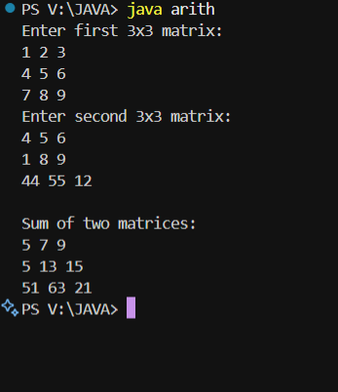
Program -02
Write a program to accept 2D array and Print Multiplication of two matrixes
Code:
import java.util.Scanner;

public class MatrixMultiplication {
public static void main(String[] args) {
Scanner sc = new Scanner(System.in);
int[][] a = new int[3][3];
int[][] b = new int[3][3];
int[][] product = new int[3][3];

System.out.println("Enter first 3x3 matrix:");
for (int i = 0; i < 3; i++)
for (int j = 0; j < 3; j++)
a[i][j] = sc.nextInt();

System.out.println("Enter second 3x3 matrix:");
for (int i = 0; i < 3; i++)
for (int j = 0; j < 3; j++)
b[i][j] = sc.nextInt();

// Multiplication logic
System.out.println("\nProduct of two matrices:");
for (int i = 0; i < 3; i++) {
for (int j = 0; j < 3; j++) {
product[i][j] = 0;
for (int k = 0; k < 3; k++)
product[i][j] += a[i][k] * b[k][j];
System.out.print(product[i][j] + " ");
}
System.out.println();
}
sc.close();
}
}
Output:
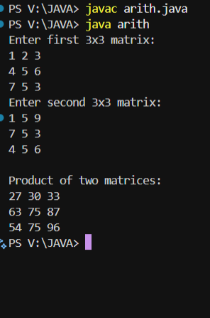

Program -03
Accept 2D array and perform following operation
- Row wise addition of matrix
- Column wise addition of matrix
- Row wise Minimum and Maximum number
- Column wise Minimum and Maximum number
CODE:
import java.util.Scanner;
public class MatrixOperations {
public static void main(String[] args) {
Scanner sc = new Scanner(System.in);
int[][] mat = new int[3][3];

System.out.println("Enter 3x3 matrix:");
for (int i = 0; i < 3; i++)
for (int j = 0; j < 3; j++)
mat[i][j] = sc.nextInt();

// a. Row wise addition
System.out.println("\nRow wise addition:");
for (int i = 0; i < 3; i++) {
int rowSum = 0;
for (int j = 0; j < 3; j++)
rowSum += mat[i][j];
System.out.println("Row " + i + ": " + rowSum);
}

// b. Column wise addition
System.out.println("\nColumn wise addition:");
for (int j = 0; j < 3; j++) {
int colSum = 0;
for (int i = 0; i < 3; i++)
colSum += mat[i][j];
System.out.println("Column " + j + ": " + colSum);
}

// c. Row wise min and max
System.out.println("\nRow wise Min and Max:");
for (int i = 0; i < 3; i++) {
int min = mat[i][0], max = mat[i][0];
for (int j = 1; j < 3; j++) {
if (mat[i][j] < min) min = mat[i][j];
if (mat[i][j] > max) max = mat[i][j];
}
System.out.println("Row " + i + " -> Min: " + min + ", Max: " + max);
}

// d. Column wise min and max
System.out.println("\nColumn wise Min and Max:");
for (int j = 0; j < 3; j++) {
int min = mat[0][j], max = mat[0][j];
for (int i = 1; i < 3; i++) {
if (mat[i][j] < min) min = mat[i][j];
if (mat[i][j] > max) max = mat[i][j];
}
System.out.println("Column " + j + " -> Min: " + min + ", Max: " + max);
}
sc.close();
}
}

OUTPUT:
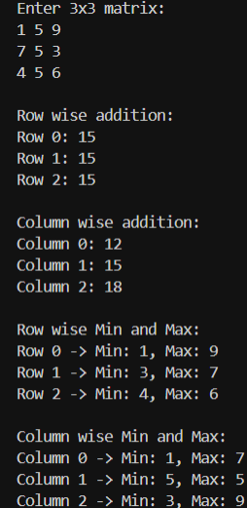
Program -04
Write a program to accept the number from user and check that number is present in the 2D array or not if the number is present return the 2D index of the present number else return number is not present.
CODE:
import java.util.Scanner;
public class Search2DArray {
public static void main(String[] args) {
Scanner sc = new Scanner(System.in);
int[][] arr = new int[3][3];

System.out.println("Enter 3x3 matrix:");
for (int i = 0; i < 3; i++)
for (int j = 0; j < 3; j++)
arr[i][j] = sc.nextInt();

System.out.print("Enter number to search: ");
int num = sc.nextInt();
boolean found = false;

for (int i = 0; i < 3; i++) {
for (int j = 0; j < 3; j++) {
if (arr[i][j] == num) {
System.out.println("Number found at index [" + i + "][" + j + "]");
found = true;
}
}
}
if (!found)
System.out.println("Number not present in array.");
sc.close();
}
}

OUTPUT:
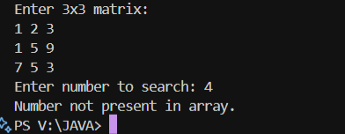

Program -05
Write a program to accept the number from user and accept the index from the number Insert the number into 1D array

CODE:
import java.util.*;

public class InsertIn1DArray {
public static void main(String[] args) {
Scanner sc = new Scanner(System.in);
int[] arr = new int[5];

System.out.println("Enter 5 elements:");
for (int i = 0; i < 5; i++)
arr[i] = sc.nextInt();

System.out.print("Enter number to insert: ");
int num = sc.nextInt();
System.out.print("Enter index (0 to 5): ");
int index = sc.nextInt();

int[] newArr = new int[6];
for (int i = 0, j = 0; i < 6; i++) {
if (i == index)
newArr[i] = num;
else
newArr[i] = arr[j++];
}

System.out.println("Array after insertion:");
System.out.println(Arrays.toString(newArr));
sc.close();
}
}

OUTPUT:
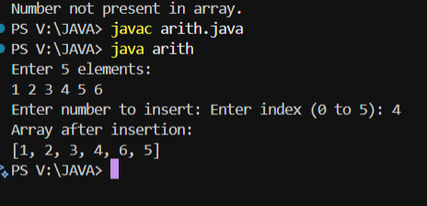
Program -06
Write a program to accept the number from user and accept the 2D index from the number Insert the number into 2D array
CODE:
import java.util.*;

public class InsertIn2DArray {
public static void main(String[] args) {
Scanner sc = new Scanner(System.in);
int[][] arr = new int[3][3];

System.out.println("Enter 3x3 matrix:");
for (int i = 0; i < 3; i++)
for (int j = 0; j < 3; j++)
arr[i][j] = sc.nextInt();

System.out.print("Enter number to insert: ");
int num = sc.nextInt();
System.out.print("Enter row index (0-2): ");
int r = sc.nextInt();
System.out.print("Enter column index (0-2): ");
int c = sc.nextInt();

arr[r][c] = num;

System.out.println("Matrix after insertion:");
for (int i = 0; i < 3; i++) {
for (int j = 0; j < 3; j++)
System.out.print(arr[i][j] + " ");
System.out.println();
}
sc.close();
}
}
OUTPUT:
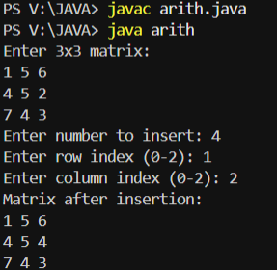

Program -07
Write a program to accept the index from the number and delete the number from 1D array
CODE:
import java.util.*;

public class DeleteIn1DArray {
public static void main(String[] args) {
Scanner sc = new Scanner(System.in);
int[] arr = new int[5];

System.out.println("Enter 5 elements:");
for (int i = 0; i < 5; i++)
arr[i] = sc.nextInt();

System.out.print("Enter index to delete (0-4): ");
int index = sc.nextInt();

int[] newArr = new int[4];
for (int i = 0, j = 0; i < 5; i++) {
if (i != index)
newArr[j++] = arr[i];
}

System.out.println("Array after deletion:");
System.out.println(Arrays.toString(newArr));
sc.close();
}
}

OUTPUT:
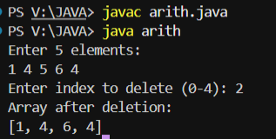

Program -08
Write a program to accept the 2D index from the number and delete the number from 2D array

CODE:

import java.util.*;

public class DeleteIn2DArray {

public static void main(String[] args) {

Scanner sc = new Scanner(System.in);

int[][] arr = new int[3][3];

System.out.println("Enter 3x3 matrix:");

for (int i = 0; i < 3; i++)

for (int j = 0; j < 3; j++)

arr[i][j] = sc.nextInt();

System.out.print("Enter row index (0-2) to delete: ");

int r = sc.nextInt();

System.out.print("Enter column index (0-2) to delete: ");

int c = sc.nextInt();

arr[r][c] = 0; // Set to zero or null value to represent deletion

System.out.println("Matrix after deletion:");

for (int i = 0; i < 3; i++) {

for (int j = 0; j < 3; j++)

System.out.print(arr[i][j] + " ");

System.out.println();

}

sc.close();

}

}

OUTPUT:

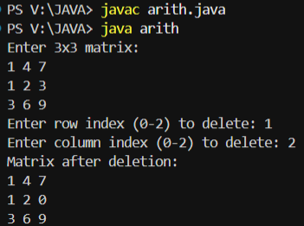

ASSIGNMENT 6
Program -01
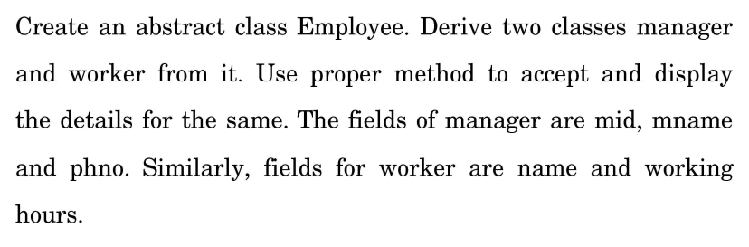

Program -02
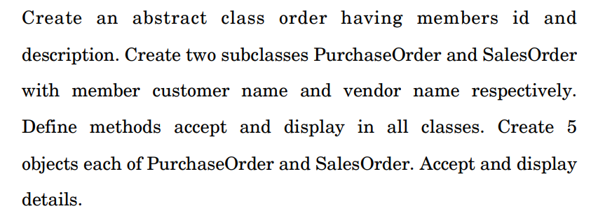

Code:

import java.util.Scanner;

// ========== Abstract Class 1: Employee ==========

abstract class Employee {

abstract void accept();

abstract void display();

}

class Manager extends Employee {

int mid;

String mname, phno;

Scanner sc = new Scanner(System.in);

void accept() {

System.out.print("Enter Manager ID: ");

mid = sc.nextInt();

sc.nextLine();

System.out.print("Enter Manager Name: ");

mname = sc.nextLine();

System.out.print("Enter Manager Phone Number: ");

phno = sc.nextLine();

}

void display() {

System.out.println("\n--- Manager Details ---");

System.out.println("ID: " + mid);

System.out.println("Name: " + mname);

System.out.println("Phone: " + phno);

}

}

class Worker extends Employee {

String name;

int hours;

Scanner sc = new Scanner(System.in);

void accept() {

System.out.print("Enter Worker Name: ");

name = sc.nextLine();

System.out.print("Enter Working Hours: ");

hours = sc.nextInt();

}

void display() {

System.out.println("\n--- Worker Details ---");

System.out.println("Name: " + name);

System.out.println("Working Hours: " + hours);

}

}

// ========== Abstract Class 2: Order ==========

abstract class Order {

int id;

String description;

abstract void accept();

abstract void display();

}

class PurchaseOrder extends Order {

String customerName;

Scanner sc = new Scanner(System.in);

void accept() {

System.out.print("Enter Purchase Order ID: ");

id = sc.nextInt();

sc.nextLine();

System.out.print("Enter Description: ");

description = sc.nextLine();

System.out.print("Enter Customer Name: ");

customerName = sc.nextLine();

}

void display() {

System.out.println("\n--- Purchase Order ---");

System.out.println("ID: " + id);

System.out.println("Description: " + description);

System.out.println("Customer Name: " + customerName);

}

}

class SalesOrder extends Order {

String vendorName;

Scanner sc = new Scanner(System.in);

void accept() {

System.out.print("Enter Sales Order ID: ");

id = sc.nextInt();

sc.nextLine();

System.out.print("Enter Description: ");

description = sc.nextLine();

System.out.print("Enter Vendor Name: ");

vendorName = sc.nextLine();

}

void display() {

System.out.println("\n--- Sales Order ---");

System.out.println("ID: " + id);

System.out.println("Description: " + description);

System.out.println("Vendor Name: " + vendorName);

}

}

// ========== Main Class ==========

public class abstractDemo {

public static void main(String[] args) {

Scanner sc = new Scanner(System.in);

int choice;

do {

System.out.println("\n============================");

System.out.println(" 1. Employee Program");

System.out.println(" 2. Order Program");

System.out.println(" 3. Exit");

System.out.println("============================");

System.out.print("Enter your choice: ");

choice = sc.nextInt();

switch (choice) {

case 1:

System.out.println("\n=== EMPLOYEE PROGRAM ===");

Manager m = new Manager();

Worker w = new Worker();

m.accept();

w.accept();

m.display();

w.display();

break;

case 2:

System.out.println("\n=== ORDER PROGRAM ===");

PurchaseOrder[] po = new PurchaseOrder[5];

SalesOrder[] so = new SalesOrder[5];

System.out.println("\nEnter 5 Purchase Orders:");

for (int i = 0; i < 5; i++) {

System.out.println("\nPurchase Order " + (i + 1));

po[i] = new PurchaseOrder();

po[i].accept();

}

System.out.println("\nEnter 5 Sales Orders:");

for (int i = 0; i < 5; i++) {

System.out.println("\nSales Order " + (i + 1));

so[i] = new SalesOrder();

so[i].accept();

}

System.out.println("\n--- Displaying Purchase Orders ---");

for (PurchaseOrder p : po)

p.display();

System.out.println("\n--- Displaying Sales Orders ---");

for (SalesOrder s : so)

s.display();

break;

case 3:

System.out.println("Exiting program. Goodbye!");

break;

default:

System.out.println("Invalid choice! Please try again.");

}

} while (choice != 3);

}

}

OUTPUT

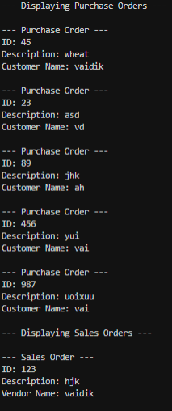

Program -03
Write a Java program to read the lines from console until the given line is “good bye”. Display those lines which contain the word “India” or “Hello”. Also count the number of lines in which pattern is found.
CODE:
import java.util.*;

public class ReadLines {
public static void main(String[] args) {
Scanner sc = new Scanner(System.in);
int count = 0; // counter for matching lines

System.out.println("Enter lines (type 'good bye' to stop):");

while (true) {
String line = sc.nextLine(); // read input line

// stop when the user types "good bye"
if (line.equalsIgnoreCase("good bye")) {
break;
}

// check if line contains "India" or "Hello"
if (line.contains("India") || line.contains("Hello")) {
System.out.println("Matched Line: " + line);
count++;
}
}

System.out.println("\nTotal lines containing 'India' or 'Hello': " + count);
sc.close();
}
}
OUTPUT:
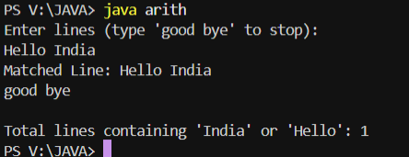

Program -04
Write an application to define an interface ‘CalculateResult’ with methods CalculateTotal(), CalculatePercentage() and CalculateGrade(). Write student class with implementation of ‘CalculateResult’. Create student object and display total marks, percentage and grade of student.
CODE:
import java.util.*;

interface CalculateResult {
void calculateTotal();
void calculatePercentage();
void calculateGrade();
}

class Student implements CalculateResult {
String name;
int marks[] = new int[5];
int total = 0;
double percentage;
String grade;

// Accept student details
void accept() {
Scanner sc = new Scanner(System.in);
System.out.print("Enter student name: ");
name = sc.nextLine();

System.out.println("Enter marks for 5 subjects:");
for (int i = 0; i < 5; i++) {
System.out.print("Subject " + (i + 1) + ": ");
marks[i] = sc.nextInt();
}
}

// Implement interface methods
public void calculateTotal() {
total = 0;
for (int m : marks)
total += m;
}

public void calculatePercentage() {
percentage = (double) total / 5.0;
}

public void calculateGrade() {
if (percentage >= 90)
grade = "A+";
else if (percentage >= 75)
grade = "A";
else if (percentage >= 60)
grade = "B";
else if (percentage >= 40)
grade = "C";
else
grade = "Fail";
}

void display() {
System.out.println("\n---- Student Result ----");
System.out.println("Name: " + name);
System.out.println("Total Marks: " + total);
System.out.println("Percentage: " + percentage + "%");
System.out.println("Grade: " + grade);
}
}

public class StudentResult {
public static void main(String[] args) {
Student s = new Student();
s.accept();
s.calculateTotal();
s.calculatePercentage();
s.calculateGrade();
s.display();
}
}
OUTPUT:
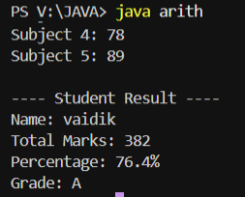

Program -05
Define Class Employee. Define another two subclasses:
(a) Temporary Employee Class (b) Permanent Employee Class
- Calculate salary for temporary employee depending upon no. of hours per month and overtime hours.
- Calculate salary for permanent employee depending upon no. of days per month.
- Override calcsal() method
- Write appropriate constructors
CODE
import java.util.*;

class Employee {
String name;
int empId;

Employee(String name, int empId) {
this.name = name;
this.empId = empId;
}

// Method to be overridden
void calcSal() {
System.out.println("Calculating salary for employee...");
}
}

// 🔹 Temporary Employee Class
class TemporaryEmployee extends Employee {
int hoursPerMonth;
int overtimeHours;
double hourlyRate;

TemporaryEmployee(String name, int empId, int hoursPerMonth, int overtimeHours, double hourlyRate) {
super(name, empId);
this.hoursPerMonth = hoursPerMonth;
this.overtimeHours = overtimeHours;
this.hourlyRate = hourlyRate;
}

@Override
void calcSal() {
double salary = (hoursPerMonth + overtimeHours) * hourlyRate;
System.out.println("\n--- Temporary Employee Details ---");
System.out.println("Name: " + name);
System.out.println("Employee ID: " + empId);
System.out.println("Hours Worked: " + hoursPerMonth);
System.out.println("Overtime Hours: " + overtimeHours);
System.out.println("Hourly Rate: " + hourlyRate);
System.out.println("Total Salary: ₹" + salary);
}
}

// 🔹 Permanent Employee Class
class PermanentEmployee extends Employee {
int workingDays;
double dailyRate;

PermanentEmployee(String name, int empId, int workingDays, double dailyRate) {
super(name, empId);
this.workingDays = workingDays;
this.dailyRate = dailyRate;
}

@Override
void calcSal() {
double salary = workingDays * dailyRate;
System.out.println("\n--- Permanent Employee Details ---");
System.out.println("Name: " + name);
System.out.println("Employee ID: " + empId);
System.out.println("Working Days: " + workingDays);
System.out.println("Daily Rate: " + dailyRate);
System.out.println("Total Salary: ₹" + salary);
}
}

// 🔹 Main Class
public class EmployeeDemo {
public static void main(String[] args) {
Scanner sc = new Scanner(System.in);

System.out.println("Enter Temporary Employee details:");
System.out.print("Name: ");
String tName = sc.nextLine();
System.out.print("Emp ID: ");
int tId = sc.nextInt();
System.out.print("Hours per month: ");
int hrs = sc.nextInt();
System.out.print("Overtime hours: ");
int ohrs = sc.nextInt();
System.out.print("Hourly rate: ");
double hrate = sc.nextDouble();

TemporaryEmployee temp = new TemporaryEmployee(tName, tId, hrs, ohrs, hrate);

System.out.println("\nEnter Permanent Employee details:");
sc.nextLine(); // clear buffer
System.out.print("Name: ");
String pName = sc.nextLine();
System.out.print("Emp ID: ");
int pId = sc.nextInt();
System.out.print("Working days in month: ");
int days = sc.nextInt();
System.out.print("Daily rate: ");
double drate = sc.nextDouble();

PermanentEmployee perm = new PermanentEmployee(pName, pId, days, drate);

// Display Salaries
temp.calcSal();
perm.calcSal();

sc.close();
}
}
OUTPUT:
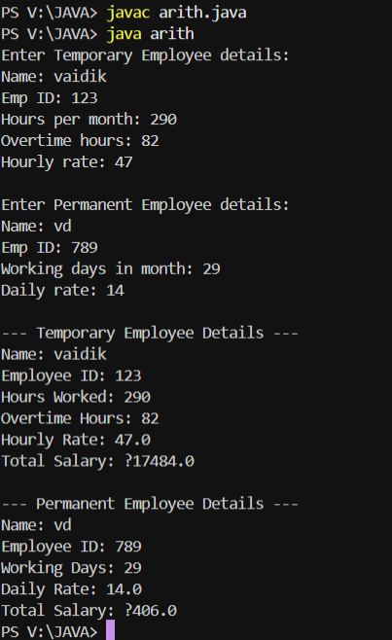
Program -06
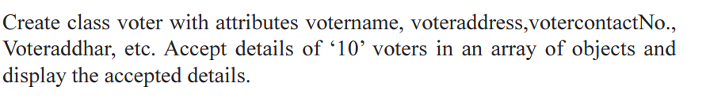
CODE:
import java.util.*;

class Voter {
String voterName;
String voterAddress;
String voterAadhar;
String voterContactNo;

// Constructor
Voter(String name, String address, String aadhar, String contact) {
this.voterName = name;
this.voterAddress = address;
this.voterAadhar = aadhar;
this.voterContactNo = contact;
}

void display() {
System.out.println("Name: " + voterName);
System.out.println("Address: " + voterAddress);
System.out.println("Aadhar No: " + voterAadhar);
System.out.println("Contact No: " + voterContactNo);
System.out.println("-----------------------------");
}

public static void main(String[] args) {
Scanner sc = new Scanner(System.in);
Voter voters[] = new Voter[10];

System.out.println("Enter details of 10 voters:");
for (int i = 0; i < 10; i++) {
System.out.println("\nVoter " + (i + 1) + " details:");
System.out.print("Name: ");
String name = sc.nextLine();
System.out.print("Address: ");
String address = sc.nextLine();
System.out.print("Aadhar No: ");
String aadhar = sc.nextLine();
System.out.print("Contact No: ");
String contact = sc.nextLine();

voters[i] = new Voter(name, address, aadhar, contact);
}

System.out.println("\n--- Voter Details ---");
for (int i = 0; i < 10; i++) {
voters[i].display();
}

sc.close();
}
}

OUTPUT:

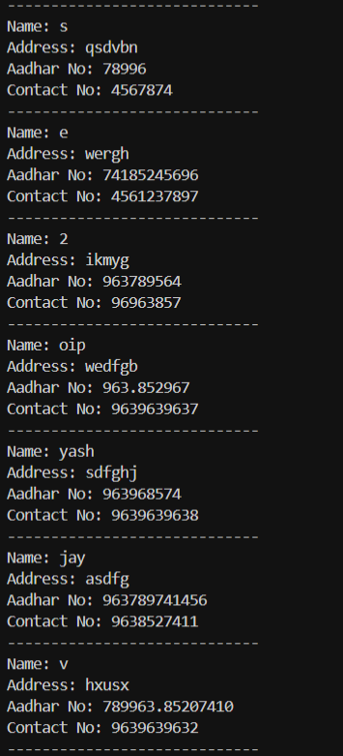

Program -07

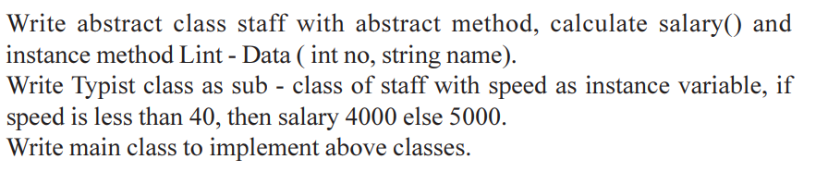

CODE:

import java.util.*;

abstract class Staff {

int no;

String name;

void initData(int no, String name) {

this.no = no;

this.name = name;

}

abstract void calculateSalary();

}

class Typist extends Staff {

int speed;

double salary;

Typist(int no, String name, int speed) {

initData(no, name);

this.speed = speed;

}

void calculateSalary() {

if (speed < 40)

salary = 4000;

else

salary = 5000;

}

void display() {

System.out.println("\n--- Typist Details ---");

System.out.println("ID: " + no);

System.out.println("Name: " + name);

System.out.println("Speed: " + speed + " wpm");

System.out.println("Salary: ₹" + salary);

}

public static void main(String[] args) {

Scanner sc = new Scanner(System.in);

System.out.print("Enter Typist ID: ");

int id = sc.nextInt();

sc.nextLine();

System.out.print("Enter Typist Name: ");

String name = sc.nextLine();

System.out.print("Enter Typing Speed (wpm): ");

int spd = sc.nextInt();

Typist t = new Typist(id, name, spd);

t.calculateSalary();

t.display();

sc.close();

}

}

OUTPUT:

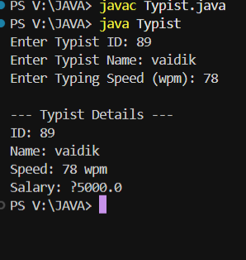

Program -08
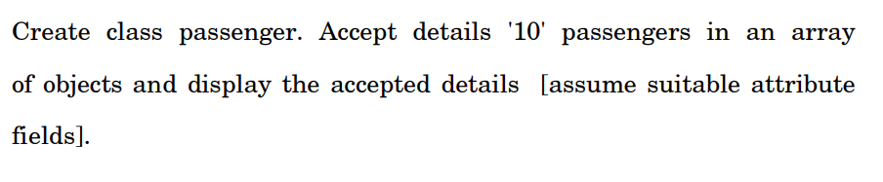

CODE:

import java.util.*;

class Passenger {

int id;

String name;

String destination;

String contact;

Passenger(int id, String name, String destination, String contact) {

this.id = id;

this.name = name;

this.destination = destination;

this.contact = contact;

}

void display() {

System.out.println("Passenger ID: " + id);

System.out.println("Name: " + name);

System.out.println("Destination: " + destination);

System.out.println("Contact: " + contact);

System.out.println("-----------------------------");

}

public static void main(String[] args) {

Scanner sc = new Scanner(System.in);

Passenger p[] = new Passenger[10];

System.out.println("Enter details of 10 passengers:");

for (int i = 0; i < 10; i++) {

System.out.println("\nPassenger " + (i + 1) + " details:");

System.out.print("ID: ");

int id = sc.nextInt();

sc.nextLine();

System.out.print("Name: ");

String name = sc.nextLine();

System.out.print("Destination: ");

String dest = sc.nextLine();

System.out.print("Contact: ");

String contact = sc.nextLine();

p[i] = new Passenger(id, name, dest, contact);

}

System.out.println("\n--- Passenger Details ---");

for (int i = 0; i < 10; i++) {

p[i].display();

}

sc.close();

}

}

OUTPUT:

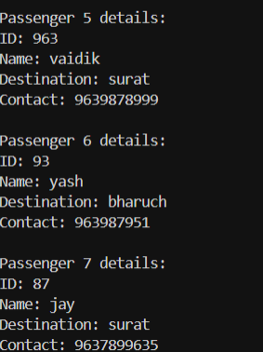

ASSIGNMENT :7
Q.1.
Write a java program to accept the details of product as productcode, productname and weight. If weight > 100 then throw an exception as InvalidProduct Exception and give the proper message. Otherwise display the product details. Define required exception class.
CODE:
import java.util.*;

class InvalidProductException extends Exception {
InvalidProductException(String msg) {
super(msg);
}
}

public class ProductException {
public static void main(String[] args) {
Scanner sc = new Scanner(System.in);
try {
System.out.print("Enter Product Code: ");
String code = sc.nextLine();
System.out.print("Enter Product Name: ");
String name = sc.nextLine();
System.out.print("Enter Product Weight: ");
double weight = sc.nextDouble();

if (weight > 100) {
throw new InvalidProductException("❌ Invalid Product: Weight exceeds 100!");
} else {
System.out.println("\n✅ Product Details:");
System.out.println("Code: " + code);
System.out.println("Name: " + name);
System.out.println("Weight: " + weight);
}
} catch (InvalidProductException e) {
System.out.println(e.getMessage());
}
sc.close();
}
}
OUTPUT:
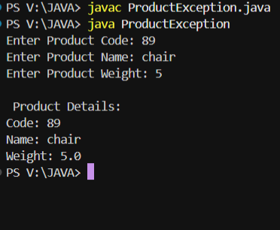
Q.2.
Write an application which will accept a number from command line. If number is not divisible by 7, then throw “notDivisibleBy7” user defined Exception.
class notDivisibleBy7 extends Exception {
notDivisibleBy7(String msg) {
super(msg);
}
}

public class DivisibleBy7 {
public static void main(String[] args) {
try {
int num = Integer.parseInt(args[0]);
if (num % 7 != 0)
throw new notDivisibleBy7("❌ Number not divisible by 7!");
else
System.out.println("✅ " + num + " is divisible by 7.");
} catch (notDivisibleBy7 e) {
System.out.println(e.getMessage());
} catch (Exception e) {
System.out.println("Please enter a valid number in command line.");
}
}
}

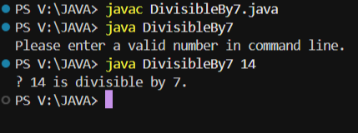

Q.3.
Accept a string from command line, if the string is in uppercase then throw user defined exception.
class UppercaseException extends Exception {
UppercaseException(String msg) {
super(msg);
}
}

public class UppercaseMain {
public static void main(String[] args) {
try {
String input = args[0];
if (input.equals(input.toUpperCase()))
throw new UppercaseException("❌ String is in UPPERCASE!");
else
System.out.println("✅ Valid String: " + input);
} catch (UppercaseException e) {
System.out.println(e.getMessage());
} catch (Exception e) {
System.out.println("Please provide a string in command line.");
}
}
}

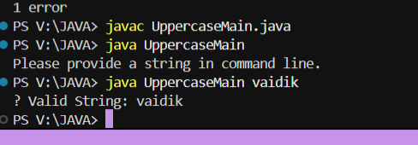

Q.4.
Write a java program to create own exception for Negative Value Exception if the user enter negative value.
import java.util.*;

class NegativeValueException extends Exception {
NegativeValueException(String msg) {
super(msg);
}
}

public class NegativeValue {
public static void main(String[] args) {
Scanner sc = new Scanner(System.in);
try {
System.out.print("Enter a number: ");
int num = sc.nextInt();
if (num < 0)
throw new NegativeValueException("❌ Negative Value Entered!");
else
System.out.println("✅ Positive Number: " + num);
} catch (NegativeValueException e) {
System.out.println(e.getMessage());
}
sc.close();
}
}
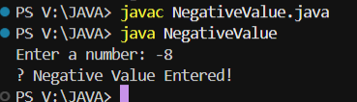

Q.5.
Write a Java program to accept email address of a user and throw a user defined exception InvalidEmailException if it starts with digit or does not contain @ symbol.
import java.util.*;

class InvalidEmailException extends Exception {
InvalidEmailException(String msg) {
super(msg);
}
}

public class EmailException {
public static void main(String[] args) {
Scanner sc = new Scanner(System.in);
try {
System.out.print("Enter Email Address: ");
String email = sc.nextLine();

if (Character.isDigit(email.charAt(0)) || !email.contains("@"))
throw new InvalidEmailException("❌ Invalid Email Address!");
else
System.out.println("✅ Valid Email: " + email);
} catch (InvalidEmailException e) {
System.out.println(e.getMessage());
}
sc.close();
}
}

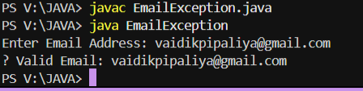

Q.6.
Write an application that will accept details of items such as items such as itemcode, description, quantity and rate.
Accept details of 5 different items in an array of objects.
Fire user defined exception << QuantityException>> and << PriceException>> if quantity or price is less than or equal to zero.
Display the accepted 5 different items details on console if there is no any error arise

import java.util.*;

class QuantityException extends Exception {
QuantityException(String msg) {
super(msg);
}
}

class PriceException extends Exception {
PriceException(String msg) {
super(msg);
}
}

class Item {
int code;
String description;
int quantity;
double rate;

Item(int code, String description, int quantity, double rate) {
this.code = code;
this.description = description;
this.quantity = quantity;
this.rate = rate;
}

void display() {
System.out.println("Code: " + code + " | Description: " + description +
" | Quantity: " + quantity + " | Rate: ₹" + rate);
}
}

public class ItemException {
public static void main(String[] args) {
Scanner sc = new Scanner(System.in);
Item[] items = new Item[5];

try {
for (int i = 0; i < 5; i++) {
System.out.println("\nEnter details for item " + (i + 1) + ":");
System.out.print("Item Code: ");
int code = sc.nextInt();
sc.nextLine();
System.out.print("Description: ");
String desc = sc.nextLine();
System.out.print("Quantity: ");
int qty = sc.nextInt();
System.out.print("Rate: ");
double rate = sc.nextDouble();

if (qty <= 0)
throw new QuantityException("❌ Quantity must be greater than zero!");
if (rate <= 0)
throw new PriceException("❌ Rate must be greater than zero!");

items[i] = new Item(code, desc, qty, rate);
}

System.out.println("\n✅ Item Details:");
for (Item i : items) i.display();

} catch (QuantityException | PriceException e) {
System.out.println(e.getMessage());
}
sc.close();
}
}

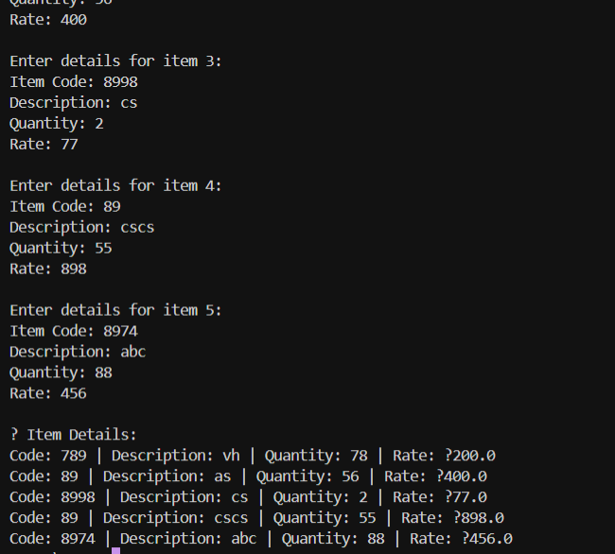

Q.9.
Write a java program to define INTERFACe CalculateResult with methods CalculateTotal(),CalculatePercentage(), CalculateGrade();
Define a Class Student which implements this interface and has appropriate method definition/ overriding for this.
Take details of n students with array of objects and display the result and if marks less than zero fire User defined Exception << ZeroMarksException>>

import java.util.*;

interface CalculateResult {
void CalculateTotal();
void CalculatePercentage();
void CalculateGrade();
}

class ZeroMarksException extends Exception {
ZeroMarksException(String msg) {
super(msg);
}
}

class Student implements CalculateResult {
String name;
int m1, m2, m3;
int total;
double percentage;
String grade;

Student(String name, int m1, int m2, int m3) {
this.name = name;
this.m1 = m1;
this.m2 = m2;
this.m3 = m3;
}

public void CalculateTotal() {
total = m1 + m2 + m3;
}

public void CalculatePercentage() {
percentage = total / 3.0;
}

public void CalculateGrade() {
if (percentage >= 75) grade = "Distinction";
else if (percentage >= 60) grade = "First Class";
else if (percentage >= 50) grade = "Second Class";
else grade = "Fail";
}

void display() {
System.out.println(name + " | Total: " + total + " | %: " + percentage + " | Grade: " + grade);
}
}

public class StudentResult {
public static void main(String[] args) {
Scanner sc = new Scanner(System.in);
try {
System.out.print("Enter number of students: ");
int n = sc.nextInt();
sc.nextLine();
Student[] s = new Student[n];

for (int i = 0; i < n; i++) {
System.out.println("\nEnter details for student " + (i + 1));
System.out.print("Name: ");
String name = sc.nextLine();
System.out.print("Marks in 3 subjects: ");
int m1 = sc.nextInt();
int m2 = sc.nextInt();
int m3 = sc.nextInt();
sc.nextLine();

if (m1 < 0 || m2 < 0 || m3 < 0)
throw new ZeroMarksException("❌ Negative marks are not allowed!");

s[i] = new Student(name, m1, m2, m3);
s[i].CalculateTotal();
s[i].CalculatePercentage();
s[i].CalculateGrade();
}

System.out.println("\n✅ Student Results:");
for (Student st : s) st.display();

} catch (ZeroMarksException e) {
System.out.println(e.getMessage());
}
sc.close();
}
}
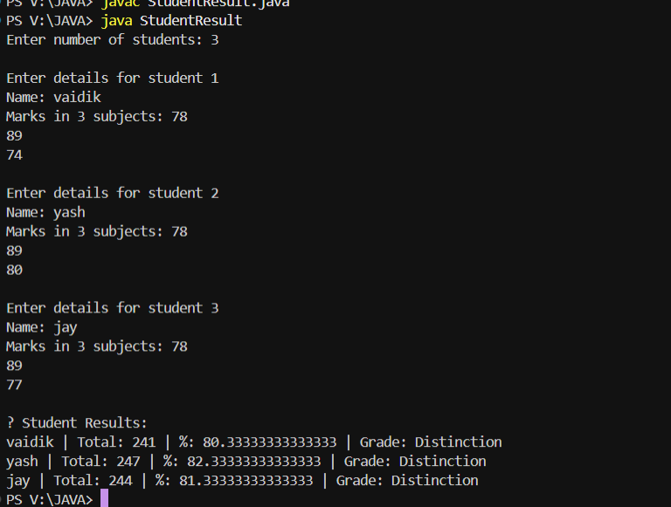

Q.9.
What is the difference between ‘Exception' and ‘error' in java?
Basis | Exception | Error
Definition | Exceptions are events that occur during program execution and disrupt the normal flow, but can be handled using try-catch. | Errors are serious issues that occur mostly outside the control of the program and cannot be easily handled.
Type | Related to problems in program logic or user input. | Related to system-level failures like memory shortage.
Recoverable? | Yes, exceptions are recoverable using exception handling. | No, errors are not recoverable.
Examples | NullPointerException, ArithmeticException, IOException | OutOfMemoryError, StackOverflowError, VirtualMachineError

Q.10.
Can we have an empty catch block? Justify
Yes, we can have it, but not recommended, because it hides the error.
try {
int a = 5 / 0;
} catch (ArithmeticException e) {
// empty catch block (bad practice)
}
System.out.println("Program continues...");

BETTER WAY:-
catch (ArithmeticException e) {
System.out.println("Error: " + e.getMessage());
}
Q.11.
What is the difference between ‘throw' and ‘throws’? And it's application?
Keyword | Use | Location | Example
throw | Used to raise exception manually | Inside method | throw new Exception("error");
throws | Used to declare exception | In method header | void test() throws Exception

Q.12.
Write a Java Program which stores the username and password in two variables. If username and password are not same, then raise “Invalid Password” with appropriate message.

class InvalidPasswordException extends Exception {

InvalidPasswordException(String msg) {

super(msg);

}

}

public class PasswordCheck {

public static void main(String[] args) {

String user = "Vaidik";

String pass = "vaidik123";

try {

if (!user.equals(pass))

throw new InvalidPasswordException("Invalid Password!");

System.out.println("Login Successful");

} catch (InvalidPasswordException e) {

System.out.println(e.getMessage());

}

}

}

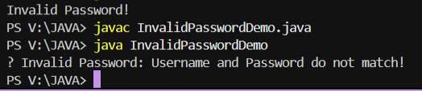

ASSIGNMENT : 8
Q1. What is multithreading? Write a multithreaded program for demonstrating following threads:
a) Display all numbers divisible by 8 from 1 to 100.
b) Display all even numbers between 51 to 100.
c) Display the message "Java is Awesome" 10 times.
Multithreading is a programming concept where multiple threads execute concurrently, sharing the same resources but performing different tasks.
Java Code:
class DivisibleBy8 extends Thread {
public void run() {
for (int i = 1; i <= 100; i++) {
if (i % 8 == 0) System.out.print(i + " ");
}
}
}
class EvenNumbers extends Thread {
public void run() {
for (int i = 51; i <= 100; i++) {
if (i % 2 == 0) System.out.print(i + " ");
}
}
}
class MessageThread extends Thread {
public void run() {
for (int i = 1; i <= 10; i++) {
System.out.println("Java is Awesome");
}
}
}
public class MultiDemo {
public static void main(String[] args) {
new DivisibleBy8().start();
new EvenNumbers().start();
new MessageThread().start();
}
}
Sample Output:
8 16 24 32 40 48 56 64 72 80 88 96
52 54 56 58 60 62 64 66 68 70 72 74 76 78 80 82 84 86 88 90 92 94 96 98 100
Java is Awesome (10 times)
Q2. Application that creates threads to print A–Z 50 times and 15 terms of Fibonacci series
class PrintAlphabets extends Thread {
public void run() {
for (int j = 1; j <= 50; j++) {
for (char c = 'A'; c <= 'Z'; c++) {
System.out.print(c + " ");
}
System.out.println();
}
}
}
class Fibonacci extends Thread {
public void run() {
int n1 = 0, n2 = 1, n3;
System.out.print(n1 + " " + n2);
for (int i = 2; i < 15; i++) {
n3 = n1 + n2;
System.out.print(" " + n3);
n1 = n2;
n2 = n3;
}
}
}
public class AlphabetsFibo {
public static void main(String[] args) {
new PrintAlphabets().start();
new Fibonacci().start();
}
}
Sample Output:
A B C ... Z (repeated 50 times)
0 1 1 2 3 5 8 13 21 34 55 89 144 233 377
Q3. Two threads displaying messages ‘n’ number of times alternately
class DisplayMessage extends Thread {
String msg;
int n;
DisplayMessage(String msg, int n) {
this.msg = msg;
this.n = n;
}
public void run() {
for (int i = 0; i < n; i++) {
System.out.println(msg);
try { Thread.sleep(500); } catch(Exception e){}
}
}
}
public class AlternateMessage {
public static void main(String[] args) {
DisplayMessage t1 = new DisplayMessage("Hello", 5);
DisplayMessage t2 = new DisplayMessage("World", 5);
t1.start();
t2.start();
}
}
Sample Output:
Hello
World
Hello
World... (alternate order)
Q4. Explain about Thread Life Cycle
A thread in Java has the following states:
1. New – Thread created but not started.
2. Runnable – After calling start(), ready for execution.
3. Running – Currently executing.
4. Waiting/Blocked – Waiting for resources or another thread.
5. Terminated – Execution completed.
Q5. Thread Synchronization (Theory + Example)
Synchronization ensures that only one thread accesses a shared resource at a time to prevent inconsistency.
It can be achieved using synchronized methods or synchronized blocks.
class Table {
synchronized void printTable(int n) {
for (int i = 1; i <= 5; i++) {
System.out.println(n * i);
try { Thread.sleep(500); } catch(Exception e) {}
}
}
}
class MyThread1 extends Thread {
Table t;
MyThread1(Table t){ this.t = t; }
public void run(){ t.printTable(5); }
}
class MyThread2 extends Thread {
Table t;
MyThread2(Table t){ this.t = t; }
public void run(){ t.printTable(100); }
}
public class SyncDemo {
public static void main(String args[]) {
Table obj = new Table();
new MyThread1(obj).start();
new MyThread2(obj).start();
}
}
Output:
5 10 15 20 25
100 200 300 400 500
Q6. Sin, Cos, Tan Calculation using Threads (Start and Join)
class SinThread extends Thread {
double degree;
SinThread(double d){ degree = d; }
public void run(){
System.out.println("Sin(" + degree + ") = " + Math.sin(Math.toRadians(degree)));
}
}
class CosThread extends Thread {
double degree;
CosThread(double d){ degree = d; }
public void run(){
System.out.println("Cos(" + degree + ") = " + Math.cos(Math.toRadians(degree)));
}
}
class TanThread extends Thread {
double degree;
TanThread(double d){ degree = d; }
public void run(){
System.out.println("Tan(" + degree + ") = " + Math.tan(Math.toRadians(degree)));
}
}
public class MathThreads {
public static void main(String[] args) throws Exception {
double degree = 45;
SinThread s = new SinThread(degree);
CosThread c = new CosThread(degree);
TanThread t = new TanThread(degree);
s.start(); s.join();
c.start(); c.join();
t.start(); t.join();
}
}
Output:
Sin(45)=0.707
Cos(45)=0.707
Tan(45)=1.0
Q7. Interthread Communication (wait(), notify(), notifyAll())
class Shared {
private int data;
boolean flag = false;
synchronized void produce(int value) {
while(flag) {
try { wait(); } catch(Exception e) {}
}
data = value;
flag = true;
System.out.println("Produced: " + data);
notify();
}
synchronized void consume() {
while(!flag) {
try { wait(); } catch(Exception e) {}
}
System.out.println("Consumed: " + data);
flag = false;
notify();
}
}
public class InterThreadDemo {
public static void main(String[] args) {
Shared s = new Shared();
new Thread(() -> {
for(int i=1;i<=5;i++) s.produce(i);
}).start();
new Thread(() -> {
for(int i=1;i<=5;i++) s.consume();
}).start();
}
}
Output:
Produced: 1
Consumed: 1
Produced: 2
Consumed: 2 ...
Q8. Multithreaded Ticket Reservation System
class Reservation implements Runnable {
int available = 1, wanted;
Reservation(int wanted) { this.wanted = wanted; }
public synchronized void run() {
String name = Thread.currentThread().getName();
if (available >= wanted) {
System.out.println(name + " booked seat.");
available -= wanted;
} else {
System.out.println("Sorry " + name + ", seat not available.");
}
}
}
public class TicketSystem {
public static void main(String[] args) {
Reservation r = new Reservation(1);
Thread t1 = new Thread(r, "Piyusha");
Thread t2 = new Thread(r, "Riya");
t1.start(); t2.start();
}
}
Output:
Piyusha booked seat.
Sorry Riya, seat not available.
Q9. Three Threads with Timed Messages
class HelloThread extends Thread {
public void run() {
while(true) {
System.out.println("Hello!");
try { Thread.sleep(1000); } catch(Exception e) {}
}
}
}
class MaskThread extends Thread {
public void run() {
while(true) {
System.out.println("Wear Mask!");
try { Thread.sleep(2000); } catch(Exception e) {}
}
}
}
class SanitizerThread extends Thread {
public void run() {
while(true) {
System.out.println("Use Sanitizer!");
try { Thread.sleep(5000); } catch(Exception e) {}
}
}
}
public class MessageThreads {
public static void main(String[] args) {
new HelloThread().start();
new MaskThread().start();
new SanitizerThread().start();
}
}
Output:
Hello!
Wear Mask!
Hello!
Use Sanitizer! ...
Q10. Difference between Extending Thread and Implementing Runnable
Extending Thread:
- Class extends Thread class.
- Cannot extend another class (single inheritance).
- Example: class MyThread extends Thread.
Implementing Runnable:
- Class implements Runnable interface.
- Can extend another class.
- Example: class MyRunnable implements Runnable.
Implementing Runnable is preferred because it promotes better design and flexibility.
Q11. Traffic Signal using Thread (Color Changing Circle)
import java.applet.*;
import java.awt.*;
public class TrafficSignal extends Applet implements Runnable {
Color c = Color.RED;
Thread t;
public void init() {
t = new Thread(this);
t.start();
}
public void run() {
try {
while(true) {
if(c == Color.RED) c = Color.GREEN;
else if(c == Color.GREEN) c = Color.YELLOW;
else c = Color.RED;
repaint();
Thread.sleep(1000);
}
} catch(Exception e) {}
}
public void paint(Graphics g) {
g.setColor(c);
g.fillOval(100,100,100,100);
}
}
Output:
A circle changing colors Red → Green → Yellow every 1 second.
Q12. Bouncing Ball Applet
import java.applet.*;
import java.awt.*;
public class BouncingBall extends Applet implements Runnable {
int x = 10, y = 50, dx = 2, dy = 2;
public void init() {
Thread t = new Thread(this);
t.start();
}
public void run() {
while(true) {
x += dx; y += dy;
if(x < 0 || x > 300) dx = -dx;
if(y < 0 || y > 300) dy = -dy;
repaint();
try { Thread.sleep(20); } catch(Exception e) {}
}
}
public void paint(Graphics g) {
g.setColor(Color.RED);
g.fillOval(x, y, 30, 30);
}
}
Output:
A ball moves and bounces within the applet window.

Assignment 9
File Handling
Q1) WAP to copy the content of one file to another, accept file names from user or as a command line argument
import java.io.*;
import java.util.Scanner;

public class CopyFile {
public static void main(String[] args) {
String sourceFile, destFile;
Scanner sc = new Scanner(System.in);

try {
// Accept file names from command line or user
if (args.length == 2) {
sourceFile = args[0];
destFile = args[1];
} else {
System.out.print("Enter source file name: ");
sourceFile = sc.nextLine();

System.out.print("Enter destination file name: ");
destFile = sc.nextLine();
}

// Create file streams
FileInputStream fis = new FileInputStream(sourceFile);
FileOutputStream fos = new FileOutputStream(destFile);

int ch;
// Read and write bytes from source to destination
while ((ch = fis.read()) != -1) {
fos.write(ch);
}

System.out.println("File copied successfully!");

// Close streams
fis.close();
fos.close();
sc.close();
}
catch (FileNotFoundException e) {
System.out.println("File not found: " + e.getMessage());
}
catch (IOException e) {
System.out.println("Error while copying file: " + e.getMessage());
}
}
}
Output Example 1 (Using user input):
Enter source file name: input.txt
Enter destination file name: output.txt
File copied successfully!

Output Example 2 (Using command-line arguments):
java CopyFile input.txt output.txt
File copied successfully!

Q2) WAP to find the longest word in the text file
import java.io.*;
import java.util.*;

public class LongestWordInFile {
public static void main(String[] args) {
Scanner sc = new Scanner(System.in);
String fileName;

try {
// Accept file name from user
System.out.print("Enter the file name: ");
fileName = sc.nextLine();

File file = new File(fileName);
Scanner fileReader = new Scanner(file);

String longestWord = "";
while (fileReader.hasNext()) {
String word = fileReader.next();

// Remove punctuation if present
word = word.replaceAll("[^a-zA-Z]", "");

if (word.length() > longestWord.length()) {
longestWord = word;
}
}

if (!longestWord.isEmpty())
System.out.println("The longest word in the file is: " + longestWord);
else
System.out.println("No valid words found in the file.");

fileReader.close();
sc.close();
}
catch (FileNotFoundException e) {
System.out.println("File not found: " + e.getMessage());
}
}
}

Output
Suppose the file sample.txt contains:
Java is a powerful programming language.

Then the output will be:
Enter the file name: sample.txt
The longest word in the file is: programming

Q3) WAP to marge the two file content into third file, ensure all the words of the third file are sorted as per dictionary order.
import java.io.*;
import java.util.*;

public class MergeAndSortFiles {
public static void main(String[] args) {
Scanner sc = new Scanner(System.in);

try {
// Accept file names
System.out.print("Enter first file name: ");
String file1 = sc.nextLine();

System.out.print("Enter second file name: ");
String file2 = sc.nextLine();

System.out.print("Enter third file name (merged output): ");
String file3 = sc.nextLine();

// List to store all words from both files
List<String> words = new ArrayList<>();

// Read first file
readFileToList(file1, words);

// Read second file
readFileToList(file2, words);

// Sort words alphabetically (dictionary order)
Collections.sort(words, String.CASE_INSENSITIVE_ORDER);

// Write sorted words into third file
FileWriter fw = new FileWriter(file3);
for (String word : words) {
fw.write(word + " ");
}
fw.close();

System.out.println("Files merged and sorted successfully into " + file3);
}
catch (IOException e) {
System.out.println("Error: " + e.getMessage());
}

sc.close();
}

// Helper method to read file contents into list
private static void readFileToList(String fileName, List<String> list) throws IOException {
File file = new File(fileName);
Scanner reader = new Scanner(file);

while (reader.hasNext()) {
String word = reader.next();
word = word.replaceAll("[^a-zA-Z]", ""); // Remove punctuation
if (!word.isEmpty()) {
list.add(word);
}
}

reader.close();
}
}
Output:
file1.txt
Java is powerful
file2.txt
Python is easy
Output in file3.txt:
easy is is Java powerful Python

Q4) WAP to read integer values from the file, sort them and print in ascending order.
import java.io.*;
import java.util.*;

public class SortNumbersFromFile {
public static void main(String[] args) {
Scanner sc = new Scanner(System.in);
String fileName;

try {
// Accept file name from user
System.out.print("Enter the file name: ");
fileName = sc.nextLine();

File file = new File(fileName);
Scanner fileReader = new Scanner(file);

List<Integer> numbers = new ArrayList<>();

// Read all integers from file
while (fileReader.hasNext()) {
if (fileReader.hasNextInt()) {
numbers.add(fileReader.nextInt());
} else {
fileReader.next(); // Skip non-integer values
}
}

// Sort the numbers in ascending order
Collections.sort(numbers);

// Print sorted numbers
System.out.println("Numbers in ascending order:");
for (int num : numbers) {
System.out.print(num + " ");
}

fileReader.close();
sc.close();
}
catch (FileNotFoundException e) {
System.out.println("File not found: " + e.getMessage());
}
}
}

Output:
Example Input File (numbers.txt):
45 12 89 33 5 78
Output
Enter the file name: numbers.txt
Numbers in ascending order:
5 12 33 45 78 89

